Cylinder Storage Cage
Model RV-43-12C

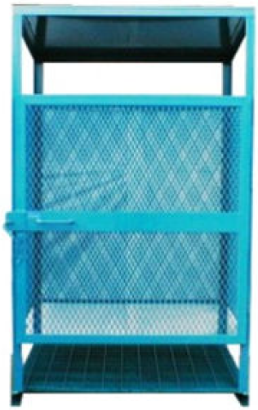

Application:
- Storage of cylinders on industrial or construction sites
- Ideal for maximum of 6 x 100lb propane cylinders or 12 typical
- oxygen & acetylene size cylinders

Specifications:
- Length = 37”
- Width = 49”
- Height = 74”
- Weight empty = 345lbs

Features:
- Allows sites to remain compliant with regulated storage needs
- Able to padlock to prevent tampering
- Vented to prevent accumulation of fuel should a cylinder leak
- Roof to prevent accumulation of snow

